


A Relational Behaviour Policy

Promoting Relational Behaviour Practices

Pinhoe Church of England School & Nursery

Approved by: | FGB Governors
Date: | July 2026
Next Review Date: | July 2027

Our Core Values
Pinhoe C of E primary School is a nurturing environment where children learn, grow, and flourish.
Central to our Christian distinctiveness, six values underpin everything we do:

Honesty, Respect, Perseverance, Thankfulness, Forgiveness and Love
We are currently transitioning to a more refined set of values linked more directly with our vision and values. These will be:

- Love
- Forgiveness
- Courage
- Peace

Relationships at Our Core
We believe a calm, positive environment is essential for effective education—where teachers have the right to teach and children have the right to learn.
Our Relational Behaviour Policy supports this through a restorative approach:
- Restorative Practices: Staff use relational methods to ensure children feel safe, secure, and emotionally supported to reach their full potential.
- Self-Esteem & Positivity: We encourage and reward positive behaviour, recognizing that high self-esteem drives excellent learning habits.
- Shared Responsibility: Positive behaviour is modelled and supported collectively by staff, parents, and peers.
- Emotional Regulation: When emotions or behaviours shift, we actively guide children through self-regulation and mutual regulation.

All staff must maintain calm, engaging learning environments, support children's emotional regulation through positive strategies, and remain contactable at all times.

At Pinhoe C of E School, positive relationships are at the heart of everything we do. All staff actively build strong connections to ensure children feel safe, trusted, and valued.
Rather than just managing behavioural symptoms, we focus on understanding and supporting each child's underlying developmental needs. We create a sense of safety, trust, and belonging through four essential pillars:
- Protection: Staff act as a source of safety by providing predictable, reliable relationships alongside clear structure, boundaries, and containment.
- Connection: Staff are physically and emotionally available, building positive relationships through active engagement, attunement, shared fun, and genuine interest in each child.
- Understanding: Staff look beyond behaviour to accept and validate children's thoughts and feelings, helping them process their emotions through curiosity, empathy, and open reflection.
- Care: Staff provide a loving and compassionate environment, looking after children's basic needs while offering soothing comfort and ongoing emotional support.

Our School Pinhoe rules
The Pinhoe rules set clear expectations for all members of our community. They are designed to build positive relationships, support inclusion, and establish boundaries so we can work together effectively.
We expect everyone to demonstrate these three core rules:
Be Safe
Be Ready
Be Respectful

At the start of every school term, each class teacher will lead the class in discussing the Pinhoe rules, they will create examples of how these rules could best be followed.
Each example should be written as a positive statement (e.g. under ‘Be Safe’ - ‘We walk inside’). The Pinhoe rules with examples should be displayed prominently in the classroom and be referred back to as needed.

Consistent expectations:
We are consistent with the expectations of our children. We expect all children to follow our rules. Some of our routines help us to maintain these:
We walk on the left hand side of the stairs and corridor.
We line up in alphabetical (register) order at all times.
When moving in between areas (from playground to class) we ensure all children are silent and in line before telling all children the expectation on them when walking into the classroom. e.g. “We will walk into our class, you need to sit on the carpet with a whiteboard and pen”.
We support the children to ‘reset’ at the start of every session. This entails a recap of the school rules and what they look like. This happens each morning, after break, after lunch and before home, this can happen more often if needed.
We walk into and out of assembly in silence.
We walk children to and collect children from the playground after break and lunch, walking them back to class.
We greet children at the door each morning using the ‘how do you want to say good morning?’ choices.

Establishing Positive Relational Approaches
Behaviour management is a collective, consistent responsibility shared by all staff.
To maintain a positive environment, all staff will:
- Hold High Expectations: Maintain consistently high standards for pupil behaviour and attitudes toward learning at all times.
- Model Positive Behaviour: Treat both colleagues and pupils with courtesy, consideration, and respect while demonstrating active cooperation.
- Uphold Professional Standards: Adhere strictly to the Teachers' Standards (Part 9, Section 7) within the classroom.

Staff must ensure they:
- Consistency: Fairly implement the relational behaviour policy and the school House system.
- Environment: Create a calm, purposeful learning space and model positive behaviour.
- Recognition: Praise and reward good behaviour, and sanction inappropriate behaviour fairly.
- Support: Boost self-esteem and implement Relational Support Plans for vulnerable pupils.
- Inclusion: Provide adapted teaching styles that ensure 'Ordinarily Available Inclusive Provision'.
- Independence: Encourage children to take on responsibilities to build self-reliance and trust.
- Wellbeing: Prioritize pastoral care, supporting each child's physical, emotional, and mental health.
- Curriculum: Deliver an engaging, inclusive, and relevant 21st-century curriculum.
- Safety: Maintain a vigilant duty of care regarding Safeguarding and Child Protection.
- Collaboration: Communicate and seek advice from Senior Leaders, the Inclusion Lead, or the Family Support Worker when needed.
- Reflection: Allow pupils opportunities to discuss, reflect on, and take responsibility for their actions.

Pinhoe School Rewards Framework
1. Day-to-Day Rewards by Key Stage
Nursery
- Individual: Verbal praise and stickers for following Pinhoe rules (e.g., "being safe" indoors).
Reception & Key Stage 1
- Individual: Stickers and house points tied to Pinhoe rules and ‘over and above’ behaviour.
- Whole Class: Bears or marbles in a jar (linked to Pinhoe rules) leading to a class reward (e.g., extra playtime) when full.
Key Stage 2
- Individual: Raffle and house points tied to Pinhoe rules and ‘over and above’ behaviour.
- Whole Class: Letter pieces earned for following Pinhoe rules. Collecting 30 pieces (typically 2–3 weeks) wins a class reward (e.g., a "cosy afternoon").

2. The House Point System (Reception to KS2)
Upon entering Reception, pupils join one of four houses: Bradbridge, Curzon, Lavington, or Stafford.
- Earning: Awarded for "over and above" achievements in learning, behaviour, core values, and manners.
- Tracking: Points translate into tokens dropped into clear visual containers outside the hall.
- Half-Termly: The winning house earns a mufti (non-uniform) day on the final day of the half-term.

3. Weekly whole school Celebration Assembly
To extend positive praise, teachers award a Star of the Week certificate to one child per class each week. Every child will receive these over the course of the academic year to ensure fairness.

4. Half-Termly & End-of-Term Awards
At the end of each half term, to extend positive praise and recognise children’s efforts and successes, teachers award the following certificates:
- Reader of the term
- Writer of the term
- Mathematician of the term
- Learning Hero (BLP) of the term
Head Teacher Certificates: any child who has earned two or more head teacher sticker awards within a single week will also be awarded a head teacher certificate at the end of the half term in which it has been achieved.
Head Teacher Awards: During the final week of each half-term, teachers nominate one child per class who has gone above and beyond or achieved something special during the half term and the Head Teacher presents them with a certificate.

Inclusion: Responding, Calming and Supporting Regulation
At Pinhoe C of E School, we recognise that some children may need additional support to manage strong feelings, regulate their emotions and feel calm, safe and ready to learn. For some children, our usual rewards and consequences may not be enough. In these cases, we consider each child’s needs individually and use appropriate strategies to support them.
Where needed, a Relational Support Plan will help adults provide consistent support throughout the day. This may identify key adults, outline how trusting relationships will be developed, and detail any changes needed to the learning or social environment so the child feels safe, secure, connected, understood and cared for.
Staff are trained to notice early signs of distress and respond before emotions become overwhelming, disruptive or unsafe. We understand that behaviour is a form of communication and may reflect an underlying need. Staff will seek to understand and respond to that need first, helping the child to regulate and return to learning when they are ready.
Staff may use language that attunes, validates and helps the child reset, such as:
“I can see this situation is very hard for you.”
“We all feel angry sometimes.”
“It’s okay to feel angry, but we need to think about how we respond.”
“Can you suggest something we could do to put this right?”
In addition, staff will use appropriate de-escalation techniques to help children feel safe, calm and supported. Where appropriate, we may seek advice from outside agencies, including our Inclusion Partner. Parents will be kept informed throughout, and their views will be listened to and included.
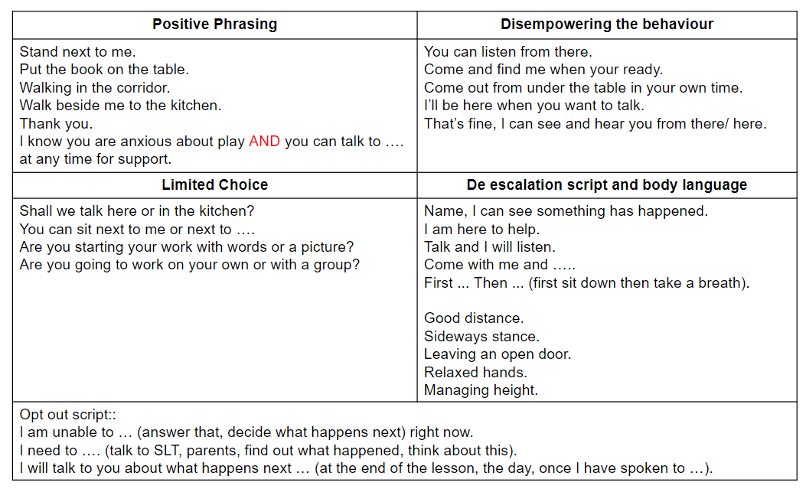

Stepped Boundaries and Consequences
At times, staff may need to use consequences. Where this is appropriate, our stepped boundaries will be followed.
Stepped boundaries and consequences are used when behaviour is deliberately unsafe, unready or disrespectful, whether a child has initiated this behaviour or responded to others in this way.
They are not used when a child is experiencing significant emotional dysregulation, sensory overwhelm or emotional overwhelm. In these situations, staff will follow the child’s Relational Support Plan, where one is in place, and use the de-escalation strategies outlined above.

Stepped Boundaries- gentle approach, use child’s name, child level, eye contact, deliver message
Deliver privately wherever possible. Adults are expected to remain calm and in control of their emotions and related behaviour.
Reminder | I noticed you chose to … (reference noticed behaviour)  This is a reminder that we need to …(Be safe, Be ready, Be respectful)  You now have the chance to make a better choice.  Thank you for listening. (Adult to walk away, do not engage).  Ensure the child knows you will pass this onto their class teacher- do this with the child where possible.
Warning 1 | Engage  Notice the behaviour  Remind what the behaviour should be and relate to Pinhoe rules  Ensure the child knows you will pass this onto their class teacher- do this with the child where possible.
Warning 2  Recorded on CPOMS by class teacher | Engage  Notice the behaviour  Remind what the behaviour should be and relate to Pinhoe rules  Put in a consequence- see below.  Ensure the child knows you will pass this onto their parents- do this with the child where possible.
SLT involvement  When class based intervention is unsuccessful or for higher level aggressive behaviour  Recorded on CPOMS by class teacher- added to by SLT if needed. | Engage  Notice the behaviour  Remind what the behaviour should be and relate to Pinhoe rules  Ensure the child knows SLT involvement is now happening.  SLT may- talk to child out of class, support the class while teacher talks to child, remove child from class for reflection time and to make a plan for positive behaviour in class.

Consequences:
Moving to partner class for 5 minutes, this can give time to reset and calm before talking about the behaviour.
Staying behind for 5 minutes at the start of break/ lunch to reflect on behaviour.
Apologising to others, e.g. if work is damaged, finding the owner and saying sorry for actions.
Work to be sent home when not completed with impositions slip (appendix 6).
Community work around the school, this is used where property has been damaged.
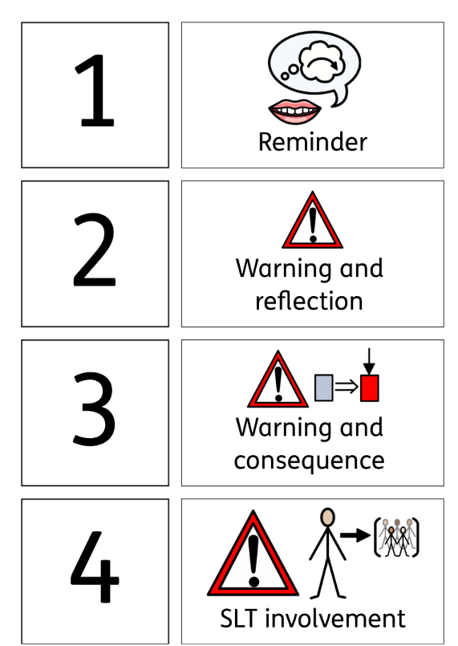

STEP 5: Out of class management
(Internal suspension in consultation with HT)
This step is for time to reflect with a member of SLT, only when behaviour is so deliberately disruptive that it is affecting the teaching of the whole class or the behaviour requires ‘serious consequences’ as described below.
- Child has time out completing their work independently or supported with a senior colleague. The time allocation for this will be based on assessment of each child’s resilience, regret and attempts to rectify. It may be 1 session (morning or afternoon) or longer.
- Removal of playtime if there is a safety risk.
- Possible behaviour contract started.
- Class Teacher/ adult in class to record on CPOMS & parents informed during the day either by phone or face to face.
- Headteacher / SLT to add to the incident record on CPOMS and add to the Suspensions log

STEP 6:
FIXED TERM EXTERNAL SUSPENSION in consultation with HT – for a significantly serious incident
- Child escorted to the Headteacher (SLT in their absence)
- Decision to externally suspend is made by the Head Teacher. If SLT is making the decision in the HT absence, then a conversation (phone call) to the Head Teacher is advised where practicable.
- Child is collected by a parent/ carer, and a Local Authority Exclusions letter is handed over.
- Suitable class English, Maths and wider Curriculum work for the duration of the External Exclusion is provided
- Possible behaviour contract started
- Headteacher / SLT to record the incident as a fixed term external suspension on suspensions log.
- All External Suspensions are reported to the Full Governing Body termly meeting.
- Upon return to school child and parent have a reintegration meeting with the Inclusion Lead and/or Head Teacher and a fresh clean start is made

Serious Consequences
Some behaviour requires quick escalation due to the potentially harmful effects of this within the school environment. These behaviours are detailed below, along with the linked consequence.
It is the class teacher's responsibility, in the first instance, to investigate any reported behaviour to ensure this behaviour is intentful and not accidental.

Behaviour displayed | Linked consequence
Serious physical violence displayed towards peers or staff | - Time out with SLT for 30 minutes - 1hr  - Internal suspension for a minimum of 1 session (morning or afternoon)  - Fixed term external suspension for a minimum of 1 session (morning or afternoon)  - Permanent exclusion
Serious damage to property
Use of racial slurs with knowledge of potential harm from using these.
Use of serious derogatory language.

A decision on which consequence is issued will be made by the Head Teacher or a member of the SLT team. This decision will take into account:
- Safeguarding concerns
- The intent of the behaviour
- The presence of remorse
- The extent of damage, hurt or harm caused
- Previous serious offences
In certain circumstances it may be necessary for the headteacher to seek the opinion of the Chair of Governors or Governing board regarding possible intervention by third party authorities.
If, in conjunction with the Chair/Governing board, the headteacher feels that the matter cannot be dealt with internally and other authorities (for example the police, social workers etc.) need to be contacted then this decision will be communicated to the parents/guardians of those pupils involved.

Step 7:
PERMANENT EXCLUSION
Serious incidents need to be treated on an individual basis and the circumstances investigated. At this stage the Exclusions Flow Chart must be followed and the Exclusion policy.

Only in exceptional circumstances would a permanent exclusion be considered. Governors will be involved and will have to follow policy and procedure.

Permanent Exclusions might be issued for the following types of incidences:
- Serious actual or threatened violence against another pupil or a member of staff;
- Sexual abuse or assault;
- Supplying an illegal drug;
- Carrying an offensive weapon;
- Serious deliberate damage to school property.
- The Executive Head would make the final decision after seeking advice from any relevant agencies/ parties/ bodies.

In this event, a letter from the Headteacher would be sent to the family inviting them to a Permanent Exclusion Hearing.
- Governors would need to form a committee and hold a panel hearing with parents attending.
- Parents have the right to appeal any decision made

- Class teachers / duty staff should deal with all incidents immediately during break or lunchtime.
- The support of more senior leaders can be sought if necessary.
- All incidents must be recorded as lunchtime / break time behaviour is also monitored half termly by senior leaders and termly by Governors.
- If the child is angry/ not ready to talk, give them cool down time. There is no point in trying to reason/discuss when the child is not ready/willing/able to.
- Remind the child of the 3 simple steps in our Pinhoe rules (Be Safe, Ready, Respectful).
- Ask the child to reflect on the 3 simple choices questions (was it safe/was it necessary/ was it kind?)
- Do not allow children to argue with you /lead you into a heated or long debate. Seek more support where necessary from the teachers on duty. HLTAs, the Family Support Worker / Inclusion Lead / Assistant Heads or Senior leaders and duty staff will be able to deal with more serious incidents on behalf of the Head Teacher.
APPENDIX 1: What is Restorative Practice?

- A restorative school is one which takes a restorative approach to resolving conflict and preventing harm.
- Restorative approaches enable those who have been harmed to convey the impact of the harm to those responsible, and for those responsible to acknowledge this impact and take steps to put it right.
- Restorative approaches refer to a range of methods and strategies which can be used both to prevent relationship-damaging incidents from happening and to resolve them if they do happen.
- Impact: Becoming a restorative school has many benefits, including increased attendance, reduced exclusions and improved achievement.
- It can also alleviate problems such as bullying, classroom disruption, truancy and poor attendance, antisocial behaviour, and disputes between pupils, their families, and members of staff.
- To be effective, restorative approaches must be in place across the school. This means all pupils, staff (including non-teaching staff), management and the wider school community must understand what acting restoratively means and how they can do it. As a result, restorative schools adopt a whole-school approach to restorative methods.

APPENDIX 2: BEHAVIOUR CONTRACT

A Behaviour Contract (means the child will be placed on a report to monitor/ track persistent low level incidences)

At any stage of the Step system a child can be considered to be placed on a Behaviour Contract, if it is deemed it would help and support a child to manage their behaviour positively. A Behaviour Contract will monitor and track progress against agreed targets which can be personalised to the child and the circumstances (see an exemplar report chart below).

Each report must have:
- Clear/realistic targets for behaviour agreed (maximum of three targets)
- Clear rewards/consequences identified for success/failure (including possible internal / external exclusion).
- Parents to be notified at the start of a behaviour chart
- Daily feedback to child and feedback to parents at the end of each day.
- Behaviour charts usually last only for one week, but for some children it may be useful to implement it for longer

APPENDIX 3:
Examples of behaviour contracts. These are editable to fit the child's need.

PINHOE C OF E SCHOOL BEHAVIOUR CONTRACT Review DAILY & WEEKLY

Name: Date:
Target/s:
 | Monday | Tuesday | Wednesday | Thursday | Friday
1st session
2nd session
afternoon

PINHOE C OF E SCHOOL BEHAVIOUR CONTRACT Review DAILY & WEEKLY

Name: Date:
Target/s:
 | Monday | Tuesday | Wednesday | Thursday | Friday
Break
Lunch

APPENDIX 4: Reflection sheets to support step 4

1. What happened (including which Pinhoe rule was broken)?
2. What were you thinking or feeling?
3. Who has been affected?
4. How have they been affected?
5. What should we do to put things right?
6. How can we do things differently in the future?

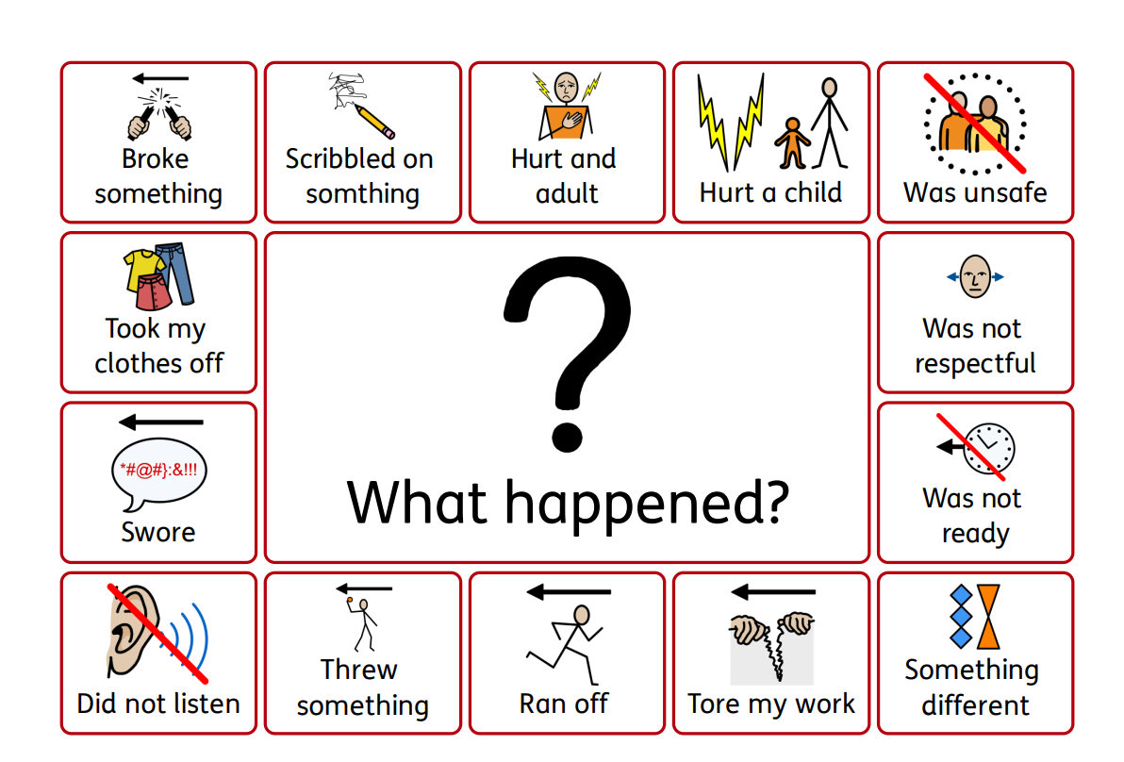
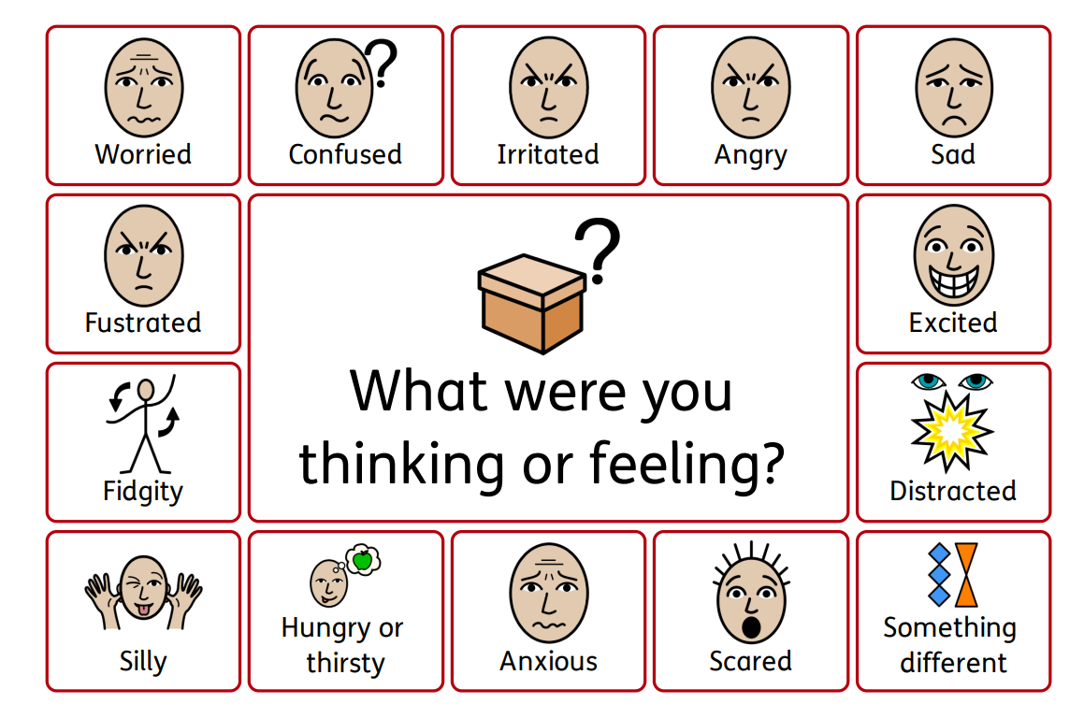

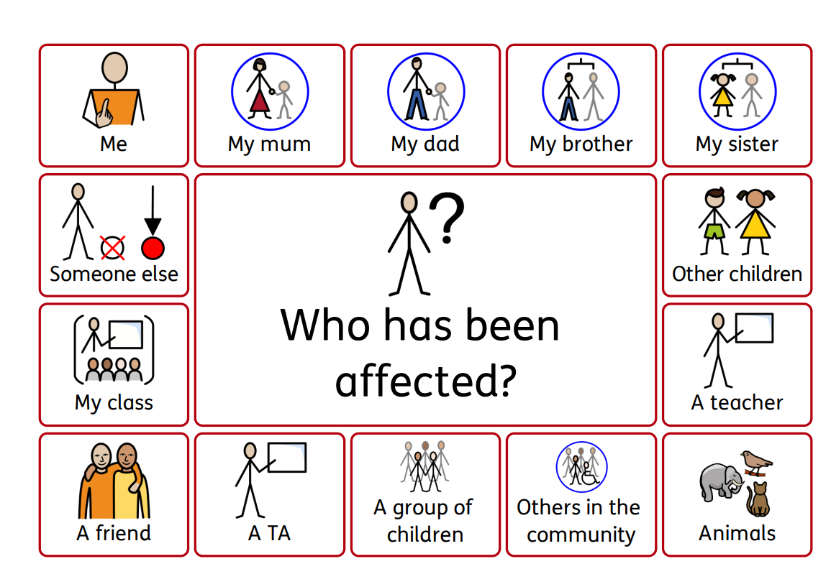

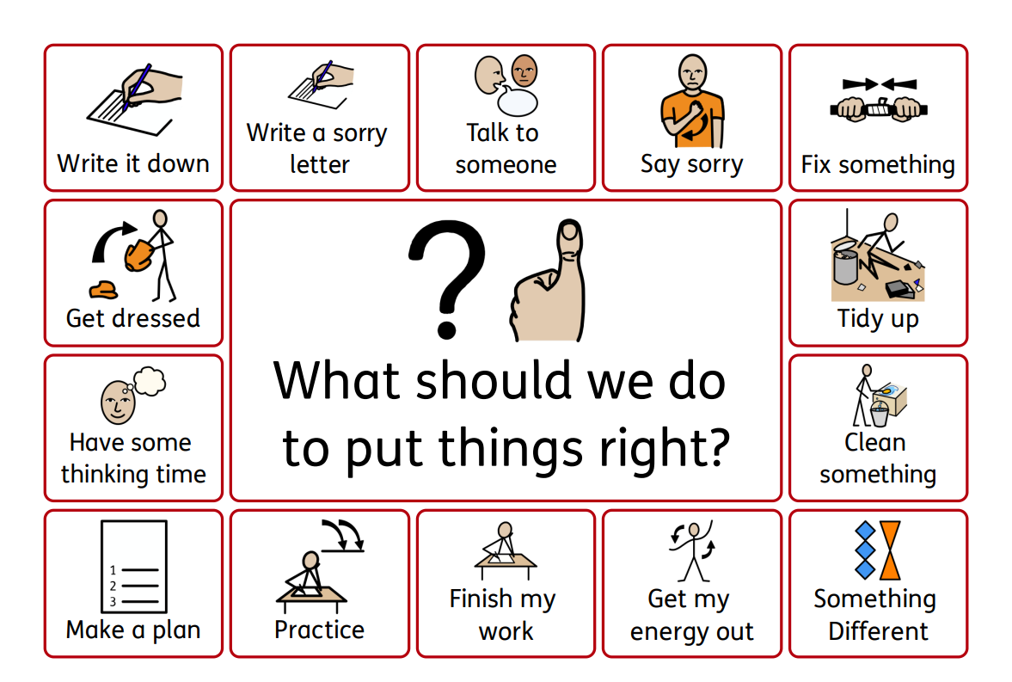

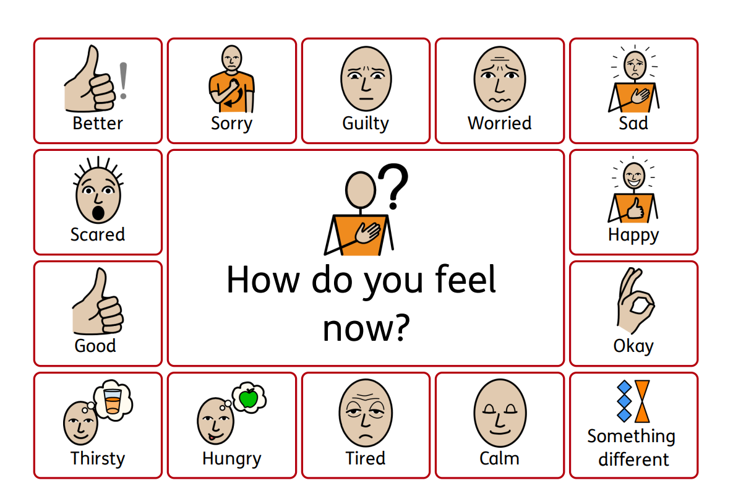

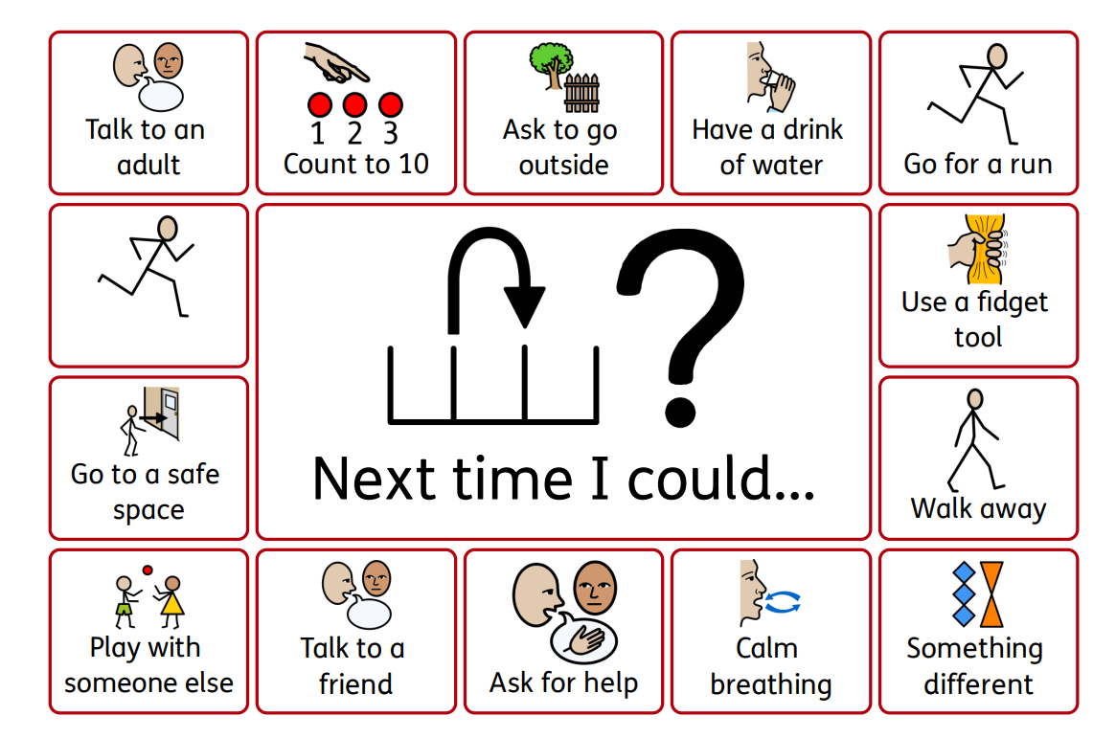

APPENDIX 5:

Pinhoe Manners: An example of being respectful
- We use manners you can hear: please, thank you, how’s your morning? have a nice day, I would like to/ please may I, indoor voices. We use a polite tone of voice
- We use manners you can see: eye contact- stop and listen, holding doors, waiting, standing to the side, applauding / congratulations, correct uniform, turn taking

Pinhoe Sitting: An example of being ready
- We are quiet so that everyone can hear and learn
- We empty our hands so that we can concentrate on the teacher
- We sit on our chairs/ floor/ mat so that everyone can concentrate
- We face the board so we can listen and look to learn

Pinhoe Walking: An example of being safe
- We walk so that we are safe
- We keep our hands to ourselves so that everyone has space
- We are quiet walking around school so that others classes can continue to learn
- We walk on the left side in corridors and stairs so that everyone has space and feels safe.

Scripted conversations
- Event: Running in the corridor
- Script: Be safe, walking thank you

- Event: Shouting
- Script: Be respectful, indoor voices thank you

- Event: Hanging out in toilets
- Script: Be safe, outside thank you

- Event: Request top listen
- Script: “Be ready” - 5 finger silent countdown - “thank you”

APPENDIX 6:
Impositions for incomplete work
In situations where a child has not completed a set amount of work within a lesson, the work will be sent home to be completed with their parent or guardian that evening and returned to their class teacher the next morning.
In these cases children will not be kept behind at break and/or lunch to complete work as we value this social time as a positive experience.
- The class teacher must be happy that the work was set at the correct level to give an achievable challenge.
- The class teacher must be happy that the time given to complete the work was appropriate.
- The class teacher must be happy that the appropriate support was provided for the child to access the work.

The form to be attached to any work sent home is below.

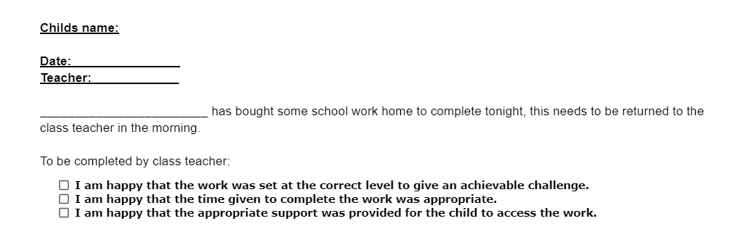

APPENDIX 7:

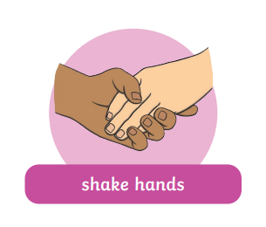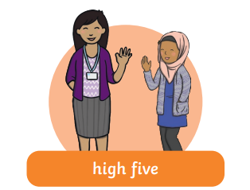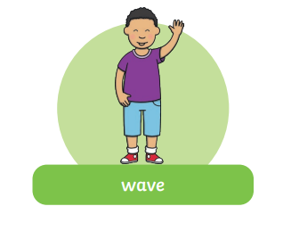

APPENDIX 8: Identifying low and higher level behaviours

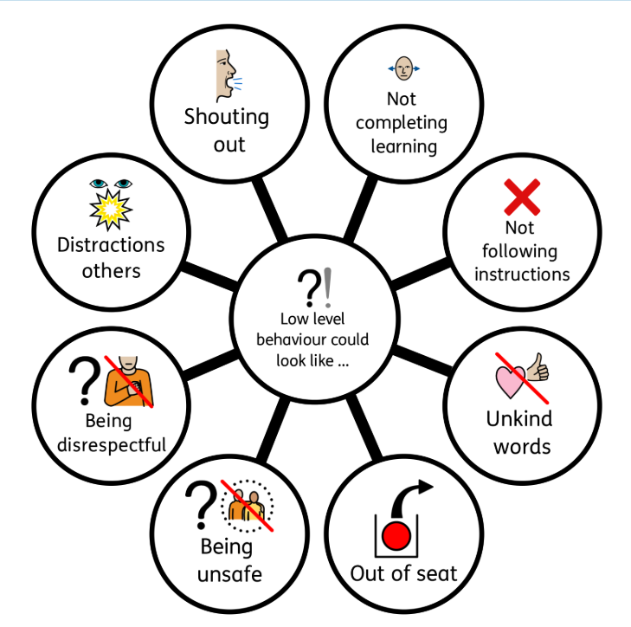

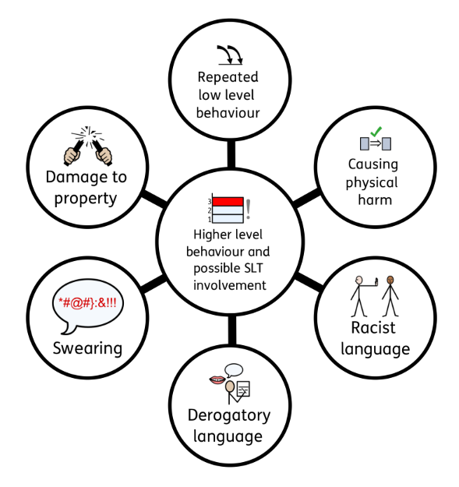

Annex 9: Blob tree
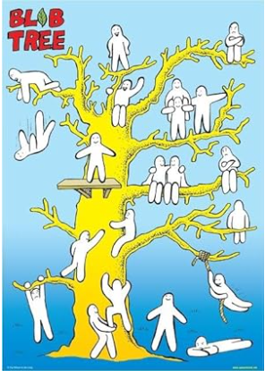

Annex 10: Whole school 5 point scale

